EE450

Lab2 Report

Yuhang Xiao

1.

DHCP is sent over UDP as shown in the figure.

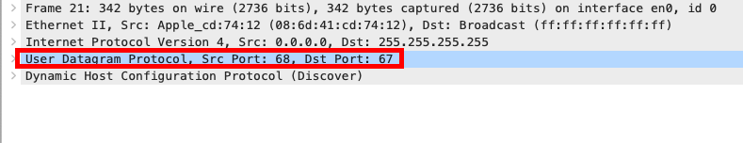

2.

Discover DHCP: src port: 68 dst port: 67

Offer DHCP: src port: 67 dst port: 68

Request DHCP: src port: 68 dst port: 67

ACK DHCP: src port: 67 dst port: 68

The port number is the same as examples.

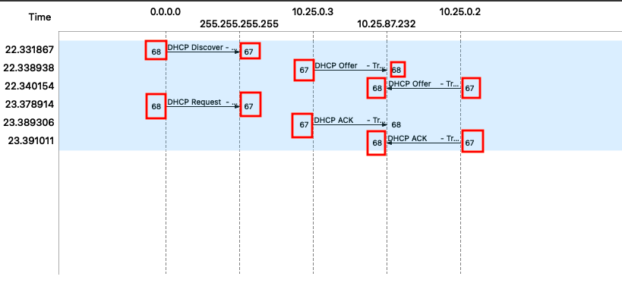

3.

The link-layer address of my host is 08:6d:41:cd:74:12.

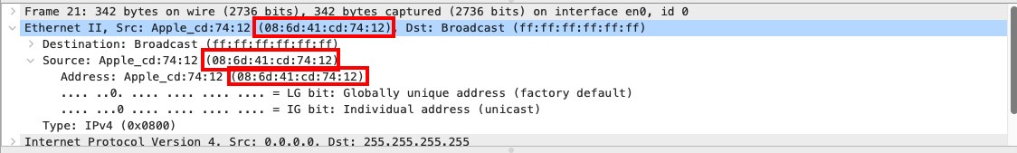

4.

The value ‘Option: (53) DHCP Message Type’ differentiates the Discover and Request message.

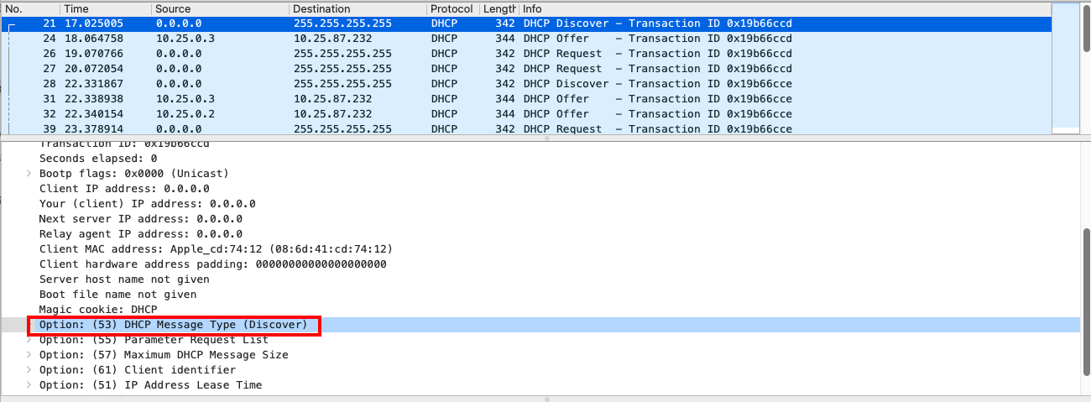

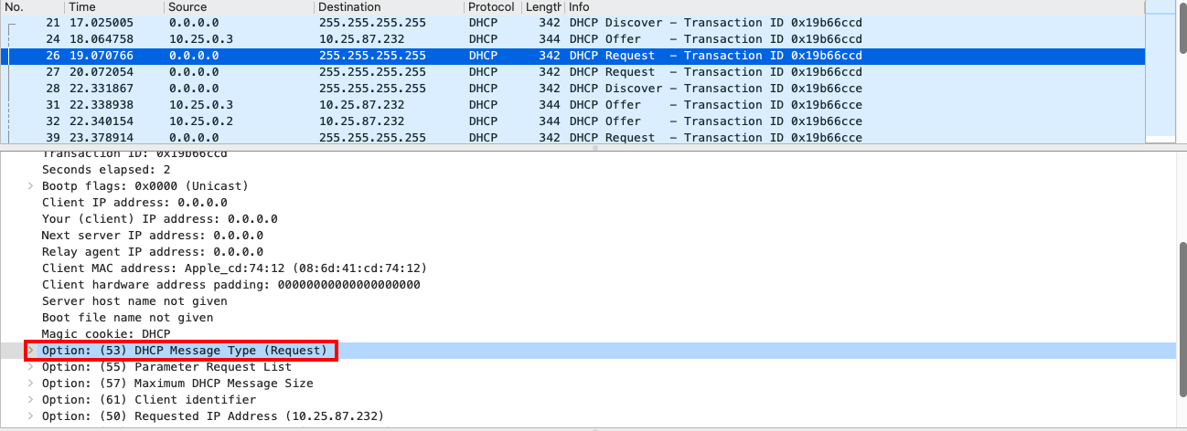

5.

First set transaction ID: 0x19b66cce

Second set transaction ID: 0x19b66ccf

The purpose is to differentiate among groups of DHCP messages.

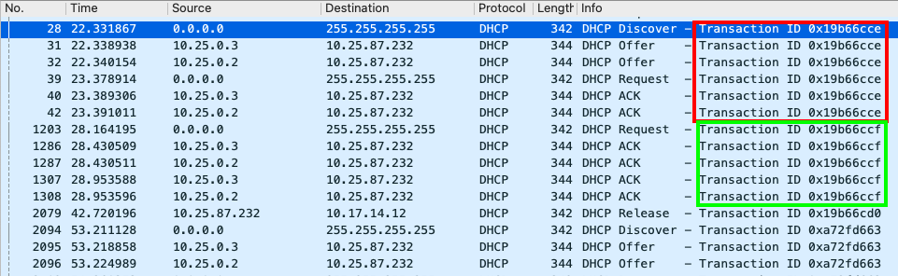

6.

Discover DHCP: SIP: 0.0.0.0 DIP: 255.255.255.255

Offer DHCP: SIP: 10.25.0.3 DIP: 10.25.87.232 and SIP: 10.25.0.2 DIP: 10.25.87.232

Request DHCP: SIP: 0.0.0.0 DIP: 255.255.255.255

ACK DHCP: SIP: 10.25.0.3 DIP: 10.25.87.232 and SIP: 10.25.0.2 DIP: 10.25.87.232

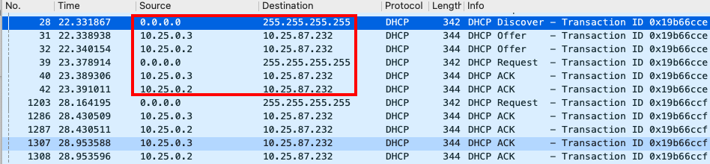

7.

The IP address of DHCP server is 10.17.14.11

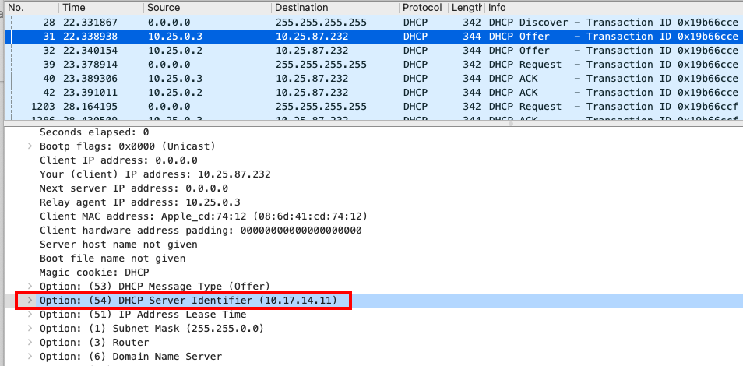

8.

The offered IP address is 10.25.87.232

Offer, Request and ACK DHCP messages contains the offered IP address as shown below.

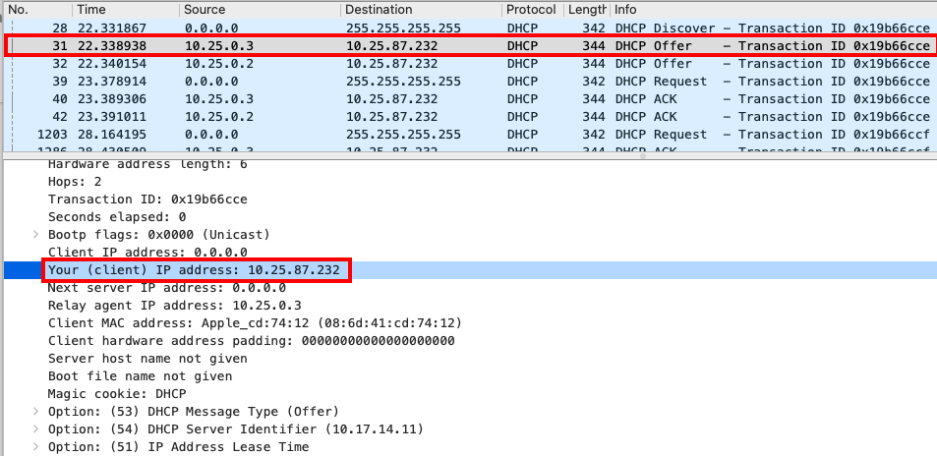

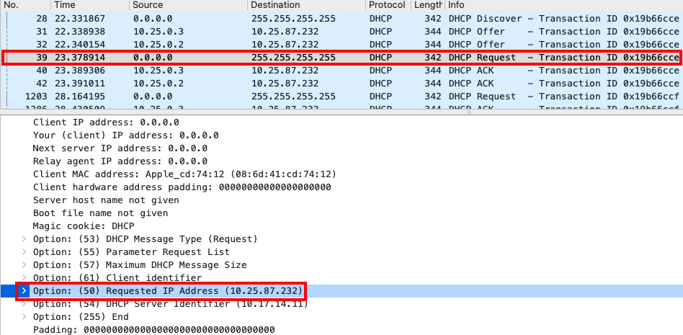

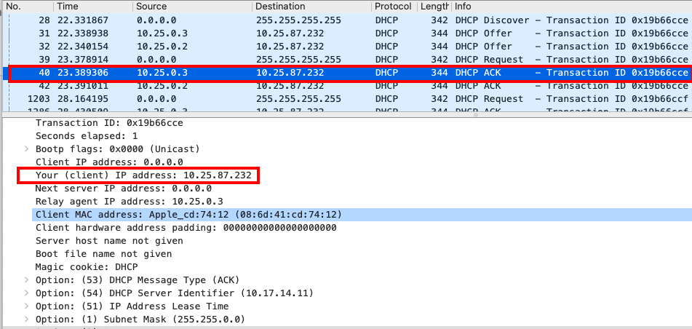

9.

In the example screenshot, the ‘Relay agent IP address: 0.0.0.0 (0.0.0.0)’ indicates that there is no relay agent. In my experiment, I have relay agent and the IP addresses are 10.25.0.3 and 10.25.0.2

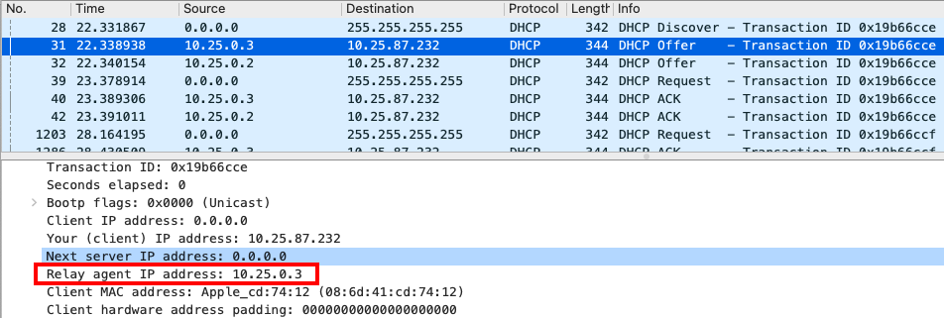

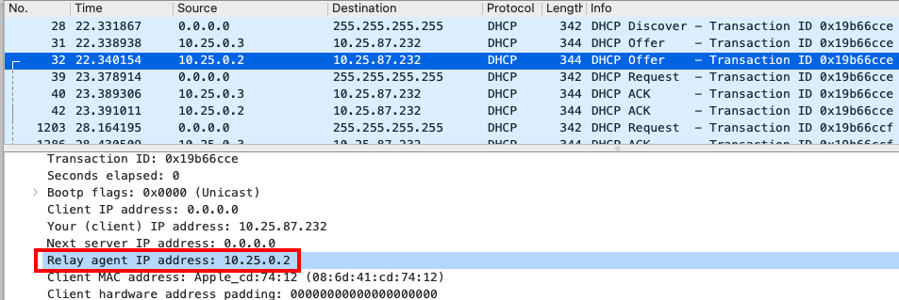

10.

Tell the client the default gateway to send messages and which subnet mask to use.

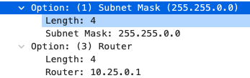

11.

The client accepted the offered IP address and requested the IP address in the Request DHCP message located in ‘Option: (50) Requested IP Address (10.25.87.232)’.



12.

The purpose of lease time is to tell the client how long can it use this offered IP address. In my experiment, the lease time is 30 minutes.

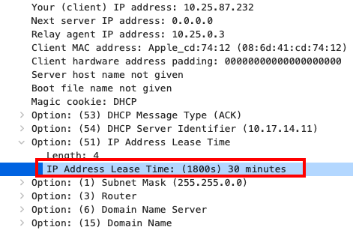

13.

The purpose of DHCP Release message is to tell the server to end the lease of the offered IP address. There is no ACK sent for the DHCP Release message as shown in the picture. If the release message is lost, the DHCP server will not reuse the offered IP address until the lease time is over.

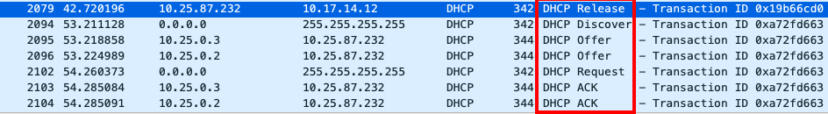

14.

There are many ARP packets sent or received during the period of exchanging DHCP packets as shown in the below picture.

Purpose:

--ARP Probe: ensure that the offered IP address is not assigned to other hosts.

--ARP Announcement: tell other hosts in the same network the associated MAC address with the offered IP address.

--Other ARP: help the host with newly-assigned IP address to find the MAC address of the router.

